Міністерство освіти і науки України Харківський національний університет радіоелектроніки

Кафедра Інформатики

Звіт

з Лабораторної роботи №1

з дисципліни

«Операційні системи»

Виконав: Перевірив:

ITIHФ-20-1 Професор

Самченко С.О. Сінельнікова Т.Ф.

Харків – 2022

**Потоки**

Необхідно розробити програму client, яка дозволятиме відправляти команди на сервер по локальній мережі по протоколу TCP / IP. У сервері для обробки кожної команди створюється власний потік. Клієнтська програма повинна дозволяти відправити команду малювання кола, прямокутника, текстового повідомлення.Кожен об'єкт в клієнтському додатку задається набором параметрів, в тому числі колір і градієнтна заливка. Відправка команди виконується по натисканні на певну клавішу. Малювання об'єктів у серверному додатку виконується на певній робочій області розміром 640х480 пікселів. Повинні відбуватися перевірки коректності заданих параметрів в командах, щоб можна було забезпечити виведення об'єктів. Малювання об'єктів повинно виконуватися за допомогою GDI +. Дані про кількість намальованих об'єктів кожного типу необхідно зберегти в реєстрі. Після першого запуску перша програма повинна поміщати іконку в Windows Tray і при натисканні комбінації клавіш Ctrl + P має виводитися вікно з інформацією про кількість намальованих об'єктів кожного типу, а при натисканні на комбінацію клавіш Alt + T ці дані повинні видалятися з реєстру.

**Source.cpp:**

#include <iostream>

#include <Windows.h>

DWORD WINAPI ThreadOne(LPVOID)

{

for (int i = 0; i < 100; ++i)

{

std::cout << "Thread #1: (" << i << ") -> value = " << rand() % 100 << std::endl;

}

return 0;

}

DWORD WINAPI ThreadTwo(LPVOID)

{

for (int i = 0; i < 100; ++i)

{

std::cout << "Thread #2: (" << i << ") -> value = " << rand() % 100 << std::endl;

}

return 0;

}

int main()

{

HANDLE threads[2];

threads[0] = CreateThread(NULL, 0, ThreadOne, nullptr, 0, NULL);

threads[1] = CreateThread(NULL, 0, ThreadTwo, nullptr, 0, NULL);

WaitForMultipleObjects(2, threads, true, INFINITE);

system("pause");

return 0;

}

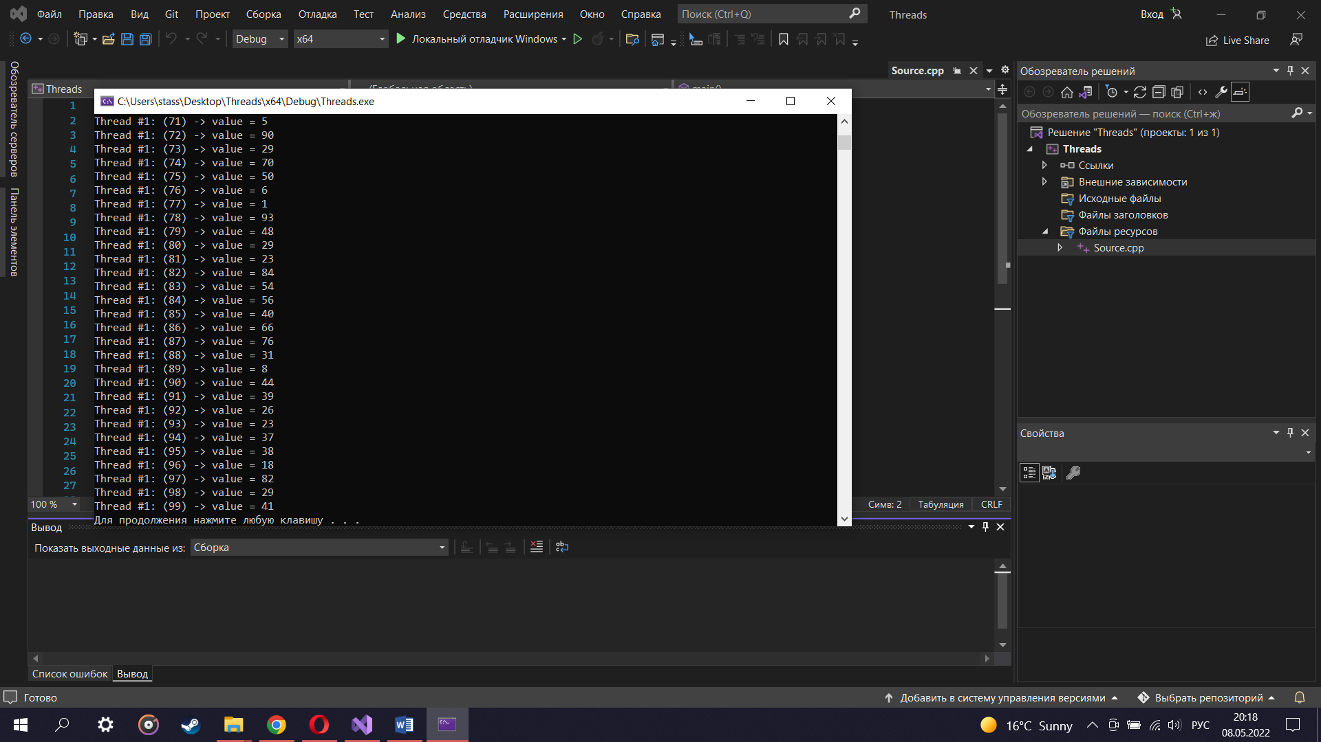

Thread #1: (0) -> value = 41Thread #2: (0) -> value = 41

Thread #2: (1) -> value = 67

Thread #2: (2) -> value =

Thread #1: (1) -> value = 67

Thread #1: (2) -> value = 34

34

Thread #2: (3) -> value = 0

Thread #2: (4) -> value = 69

Thread #2: (5) -> value = 24

Thread #2: (6) -> value = 78

Thread #2: (7) -> value = 58

Thread #2: (8) -> value = 62

Thread #2: (9) -> value = 64

Thread #2: (10) -> value = 5

Thread #2: (11) -> value = 45

Thread #1: (3) -> value = 0

Thread #1: (4) -> value = 69

Thread #2: (12) -> value = 81

Thread #1: (5) -> value = 24

Thread #2: (13) -> value = 27

Thread #1: (6) -> value = 78

Thread #1: (7) -> value = 58Thread #2: (14) -> value = 61

Thread #1: (8) -> value = 62

Thread #1: (9) -> value = Thread #2: (15) -> value = 64

91

Thread #2: (16) -> value = Thread #1: (10) -> value = 5

95

Thread #2: (Thread #1: (11) -> value = 17) -> value = 42

45

Thread #1: (12) -> value = 81

Thread #1: (13) -> value = 27

Thread #1: (14) -> value = 61

Thread #1: (15) -> value = 91

Thread #1: (16) -> value = 95

Thread #1: (17) -> value = 42

Thread #1: (18) -> value = 27

Thread #1: (19) -> value = Thread #2: (18) -> value = 27

Thread #2: (19) -> value = 36

Thread #2: (20) -> value = 91

Thread #2: (21) -> value = 4

Thread #2: (22) -> value = 2

Thread #2: (23) -> value = 53

Thread #2: (24) -> value = 92

Thread #2: (25) -> value = 82

Thread #2: (26) -> value = 21

Thread #2: (27) -> value = 16

Thread #2: (28) -> value = 18

Thread #2: (29) -> value = 95

Thread #2: (30) -> value = 47

Thread #2: (31) -> value = 26

Thread #2: (32) -> value = 71

Thread #2: (33) -> value = 38

Thread #2: (34) -> value = 69

Thread #2: (35) -> value = 12

Thread #2: (36) -> value = 67

Thread #2: (37) -> value = 36

Thread #1: (20) -> value = 99

Thread #2: (38) -> value = 91

Thread #1: (21) -> value = 35

Thread #2: (39) -> value = 94

Thread #2: (40) -> value = 3

Thread #2: (41) -> value = 11

Thread #2: (42) -> value = 22

Thread #2: (43) -> value = 33

Thread #2: (44) -> value = 73

Thread #2: (45) -> value = 4

Thread #1: (22) -> value = 64

Thread #2: (46) -> value = 41

Thread #2: (47) -> value = 11

Thread #2: (48) -> value = 2

Thread #1: (23) -> value = 53

Thread #2: (49) -> value = 68

Thread #2: (50) -> value = 53

Thread #1: (24) -> value = 47

Thread #2: (51) -> value = 44

92

Thread #1: (25) -> value = 82

Thread #1: (26) -> value = 21

Thread #1: (27) -> value = 16

Thread #1: (28) -> value = 18

Thread #1: (29) -> value = 95

Thread #1: (30) -> value = 47

Thread #1: (31) -> value = 26

Thread #1: (32) -> value = 71

Thread #1: (33) -> value = 38

Thread #1: (34) -> value = 69

Thread #1: (35) -> value = 12

Thread #1: (36) -> value = Thread #2: (52) -> value = 62

Thread #2: (53) -> value = 57

Thread #2: (54) -> value = 37

Thread #2: (55) -> value = 59

Thread #2: (56) -> value = 23

Thread #2: (57) -> value = 41

Thread #2: (58) -> value = 29

Thread #2: (59) -> value = 78

Thread #2: (60) -> value = 16

Thread #2: (61) -> value = 35

Thread #2: (62) -> value = 67

Thread #1: (37) -> value = 90

Thread #2: (63) -> value = 42

Thread #2: (64) -> value = 88

Thread #2: (65) -> value = 6

Thread #2: (66) -> value = 40

Thread #2: (67) -> value = 42

Thread #2: (68) -> value = 64

Thread #2: (69) -> value = 48

Thread #2: (70) -> value = 46

Thread #2: (71) -> value = 5

Thread #2: (72) -> value = 90

Thread #2: (73) -> value = 99

Thread #1: (38) -> value = 35

Thread #1: (39) -> value = 94

Thread #1: (40) -> value = 29

Thread #2: (74) -> value = 70

Thread #2: (75) -> value = 50

Thread #2: (76) -> value = 6

Thread #2: (77) -> value = 1

Thread #2: (78) -> value = 3

Thread #1: (41) -> value = 93

Thread #2: (79) -> value = 48

Thread #2: (80) -> value = 29

Thread #2: (81) -> value = 23

Thread #2: (82) -> value = 84

Thread #2: (83) -> value = 54

Thread #2: (84) -> value = 11

Thread #1: (42) -> value = 56

Thread #2: (85) -> value = 40

Thread #2: (86) -> value = 66

Thread #2: (87) -> value = 76

Thread #2: (88) -> value = 31

Thread #2: (89) -> value = 8

Thread #2: (90) -> value = 44

Thread #2: (91) -> value = 39

Thread #2: (92) -> value = 26

Thread #2: (93) -> value = 23

Thread #2: (94) -> value = 37

Thread #2: (95) -> value = 38

Thread #2: (96) -> value = 18

Thread #2: (97) -> value = 82

Thread #2: (98) -> value = 29

Thread #2: (99) -> value = 41

22

Thread #1: (43) -> value = 33

Thread #1: (44) -> value = 73

Thread #1: (45) -> value = 64

Thread #1: (46) -> value = 41

Thread #1: (47) -> value = 11

Thread #1: (48) -> value = 53

Thread #1: (49) -> value = 68

Thread #1: (50) -> value = 47

Thread #1: (51) -> value = 44

Thread #1: (52) -> value = 62

Thread #1: (53) -> value = 57

Thread #1: (54) -> value = 37

Thread #1: (55) -> value = 59

Thread #1: (56) -> value = 23

Thread #1: (57) -> value = 41

Thread #1: (58) -> value = 29

Thread #1: (59) -> value = 78

Thread #1: (60) -> value = 16

Thread #1: (61) -> value = 35

Thread #1: (62) -> value = 90

Thread #1: (63) -> value = 42

Thread #1: (64) -> value = 88

Thread #1: (65) -> value = 6

Thread #1: (66) -> value = 40

Thread #1: (67) -> value = 42

Thread #1: (68) -> value = 64

Thread #1: (69) -> value = 48

Thread #1: (70) -> value = 46

Thread #1: (71) -> value = 5

Thread #1: (72) -> value = 90

Thread #1: (73) -> value = 29

Thread #1: (74) -> value = 70

Thread #1: (75) -> value = 50

Thread #1: (76) -> value = 6

Thread #1: (77) -> value = 1

Thread #1: (78) -> value = 93

Thread #1: (79) -> value = 48

Thread #1: (80) -> value = 29

Thread #1: (81) -> value = 23

Thread #1: (82) -> value = 84

Thread #1: (83) -> value = 54

Thread #1: (84) -> value = 56

Thread #1: (85) -> value = 40

Thread #1: (86) -> value = 66

Thread #1: (87) -> value = 76

Thread #1: (88) -> value = 31

Thread #1: (89) -> value = 8

Thread #1: (90) -> value = 44

Thread #1: (91) -> value = 39

Thread #1: (92) -> value = 26

Thread #1: (93) -> value = 23

Thread #1: (94) -> value = 37

Thread #1: (95) -> value = 38

Thread #1: (96) -> value = 18

Thread #1: (97) -> value = 82

Thread #1: (98) -> value = 29

Thread #1: (99) -> value = 41

Для продолжения нажмите любую клавишу . . .